PLEASE DO NOT USE YOUR IPHONE OR ANY APPLE PRODUCT (I.E. MAC COMPUTER) TO SUBMIT YOUR FORM, AS YOU WILL HAVE TO RE-SUBMIT AND PAY $10 TWICE

Open your browser and enter the following URL:
KOG Onb
oarding for CAN Check Requests

https://kog.chfs.ky.gov/public/requestaccount/
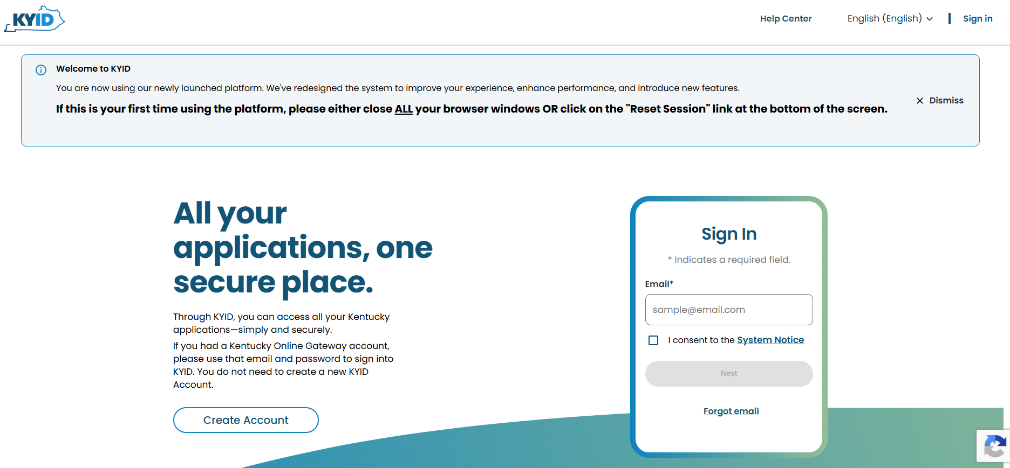
Click on Create Account button and then Get Started.
NOTE: The provided E-Mail address will be used for the account username.
Go through all 5 steps (you can skip the backup e-mail step if you do not have one) and once your account has been established, log in.

Under Apps, you will search for Adam Walsh Child Abuse Neglect Check. Click on that option and begin the process.
At the top left, from the dropdown word “Form” select “DPP-156”
- On the DPP-156, select “Public School Employee”
- Close to the end of the form under “Entity Requesting Information”, please put Ashland Independent Schools, 1820 Hickman Street, Ashland, KY 41101

- Check the box “in addition” and list my e-mail to receive a copy of your results: amy.wessel@ashland.kyschools.us
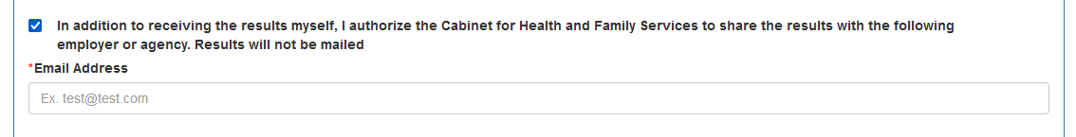
- Digitally sign and Pay $10.00 online and make sure you “Submit”.
- It will then process and e-mail you a receipt.
- You will receive an e-mail once it’s been processed with the results. As long as you have listed my e-mail address to receive a copy, I will receive the same e-mail.

Thank you!

